**BUS RESERVATION SYSTEM**

**EXPERIMENT-4**

**To Perform the Function Oriented Program**

**DFD OR STRUCTURED CHART**

**Level 0** - This diagram shows the overall system as a single process with external entities.

* External entities include driver, helper , cleaner , and the database system.
* Arrows represent the flow of data between the external entities and the system.

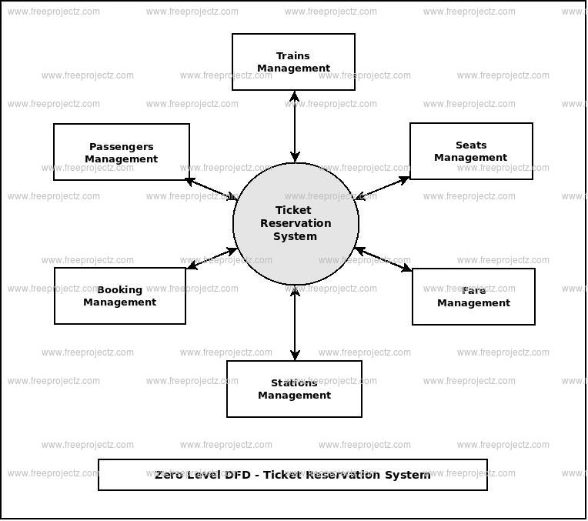

**Level 1-**bus Reservation process

* Ticket Collection Process
* Bus health check Process
* Report Generation Process
* Database Management Process

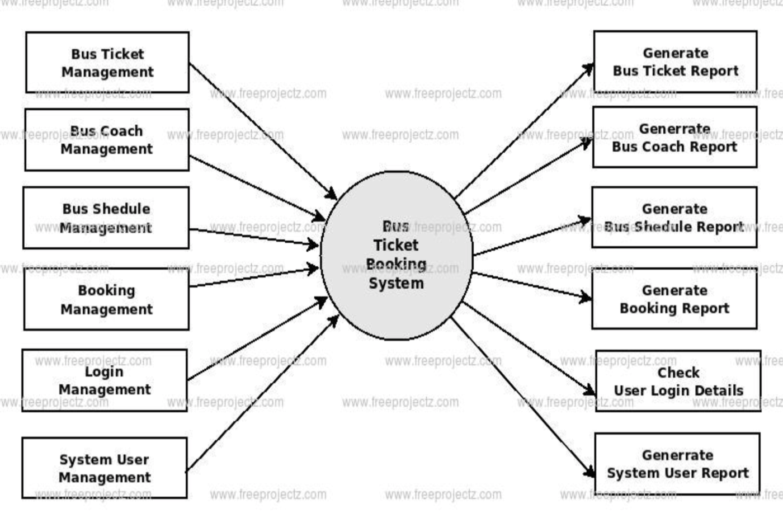

**Level 2 -**These Level 2 DFDs provide a more detailed view of how specific processes, such as different types of bus reservation and ticket generation, are carried out within the bus reservation System. Each subprocess has its own set of inputs, outputs, and data stores, helping to further refine the understanding of the system's functionality.

